TROPICAL PARTY
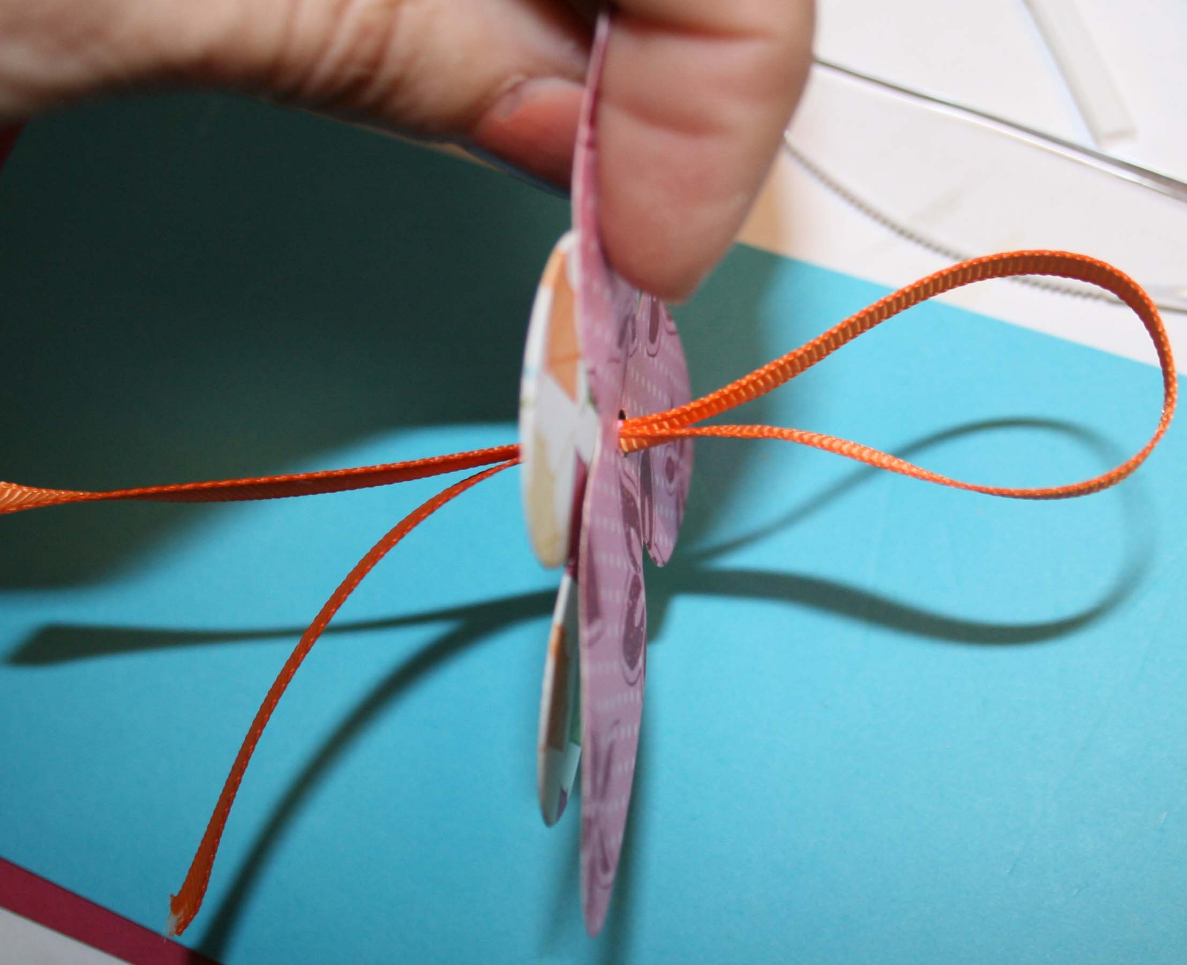 | Use crop a dile to enlarge hole created when images cut with Big Shot Die – Island Floral.  Cut length of ribbon and feed both ends to front of flowers
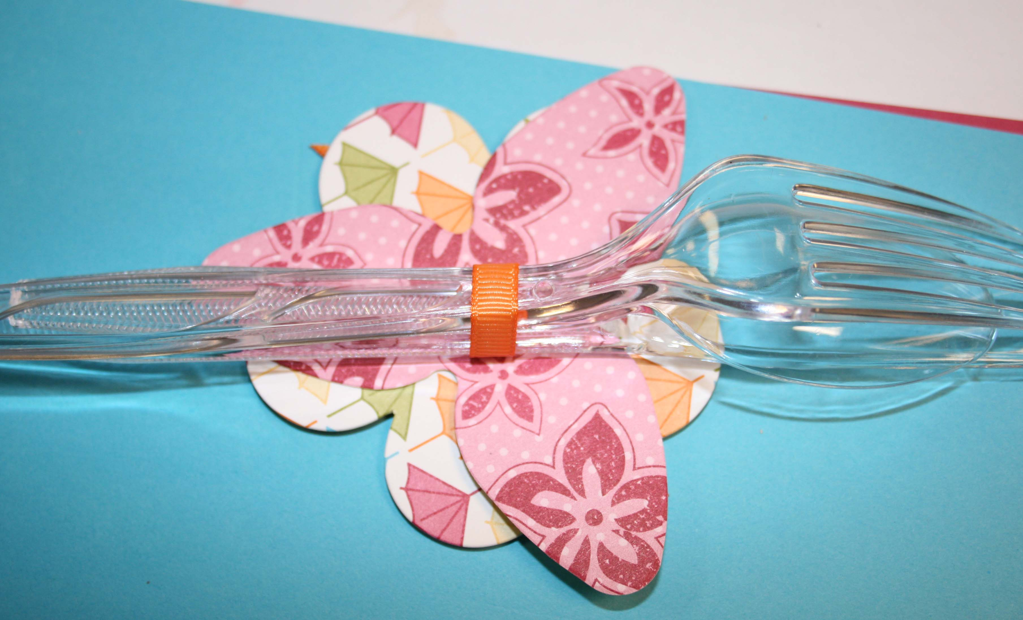 | Slip silverware through loop and cinch tight
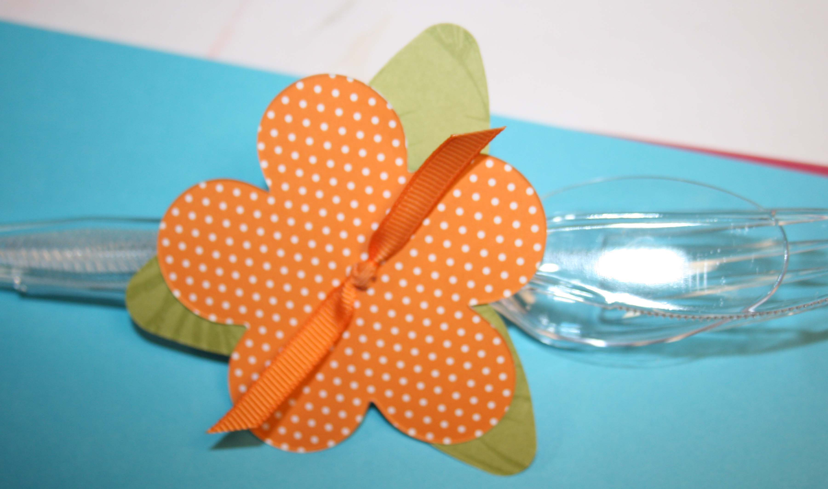 | Knot ribbon and trim to desired length.
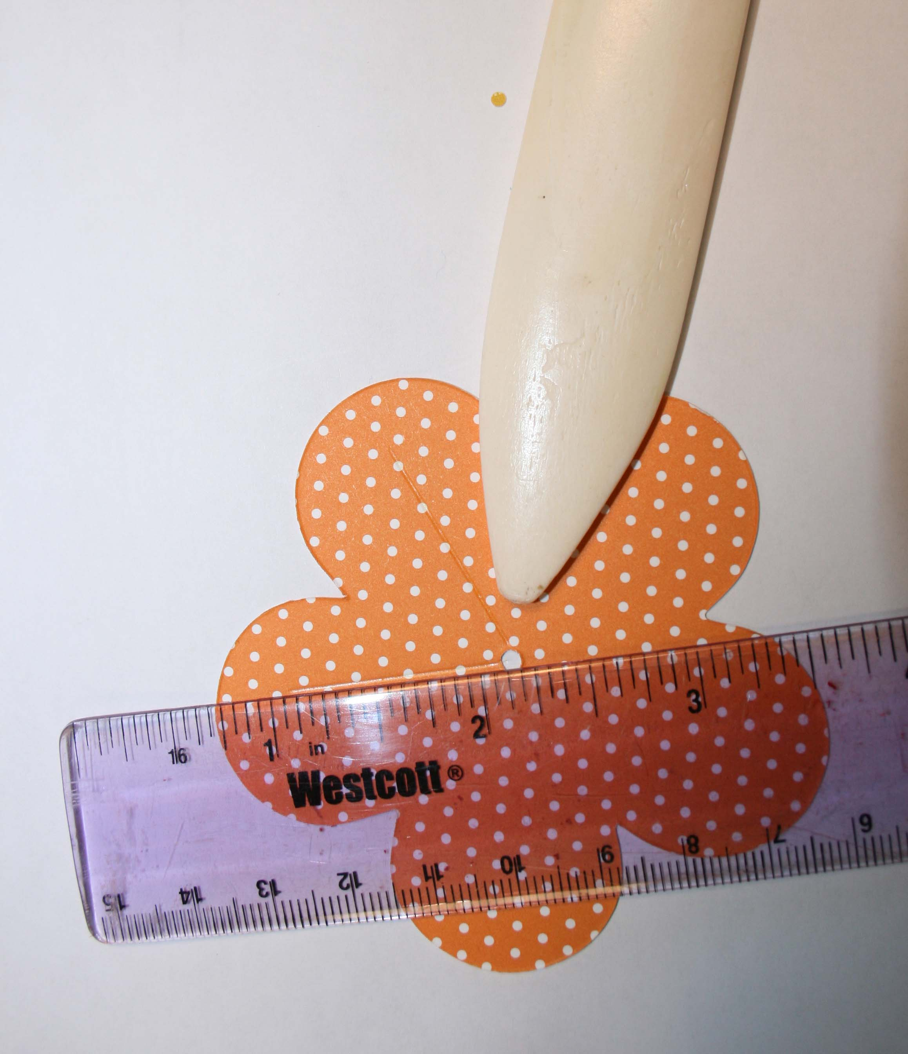 | Score 1 inch lines from center hole out towards each petal (5 score lines)
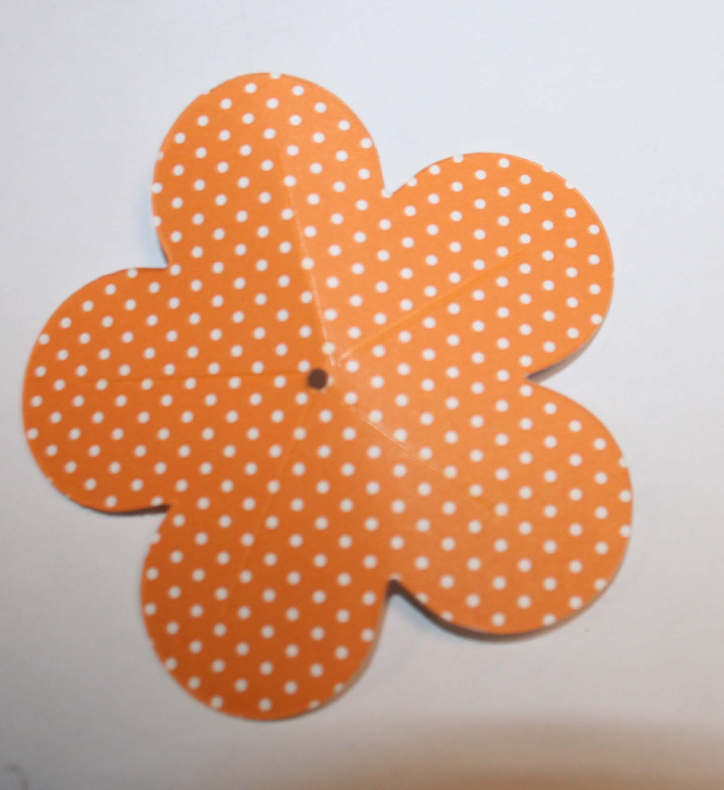
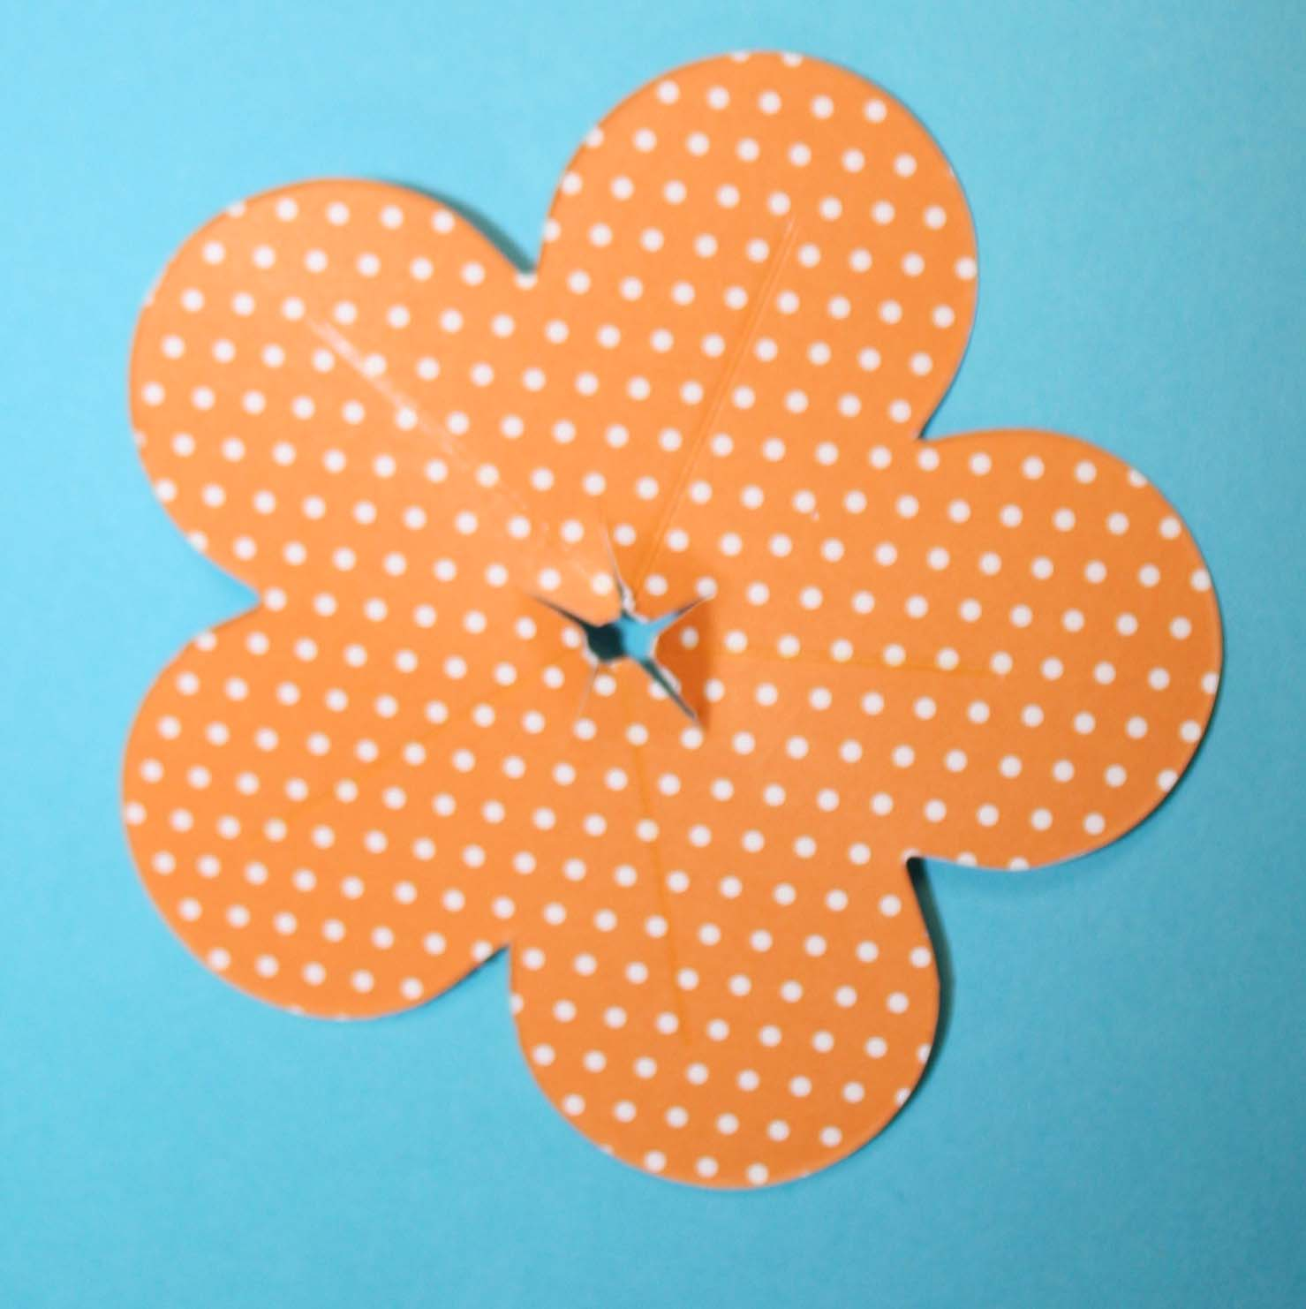 | Make small snips between score lines created
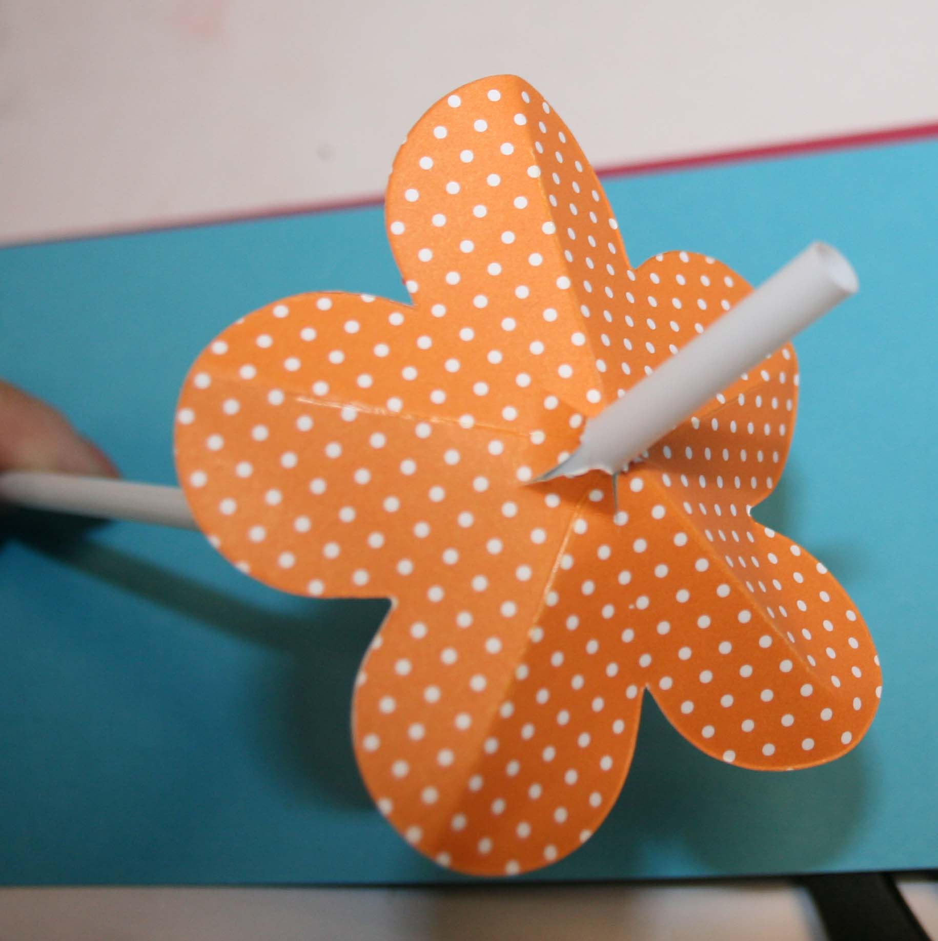 | Insert straw through opening. Crease along score lines to give flower dimension.
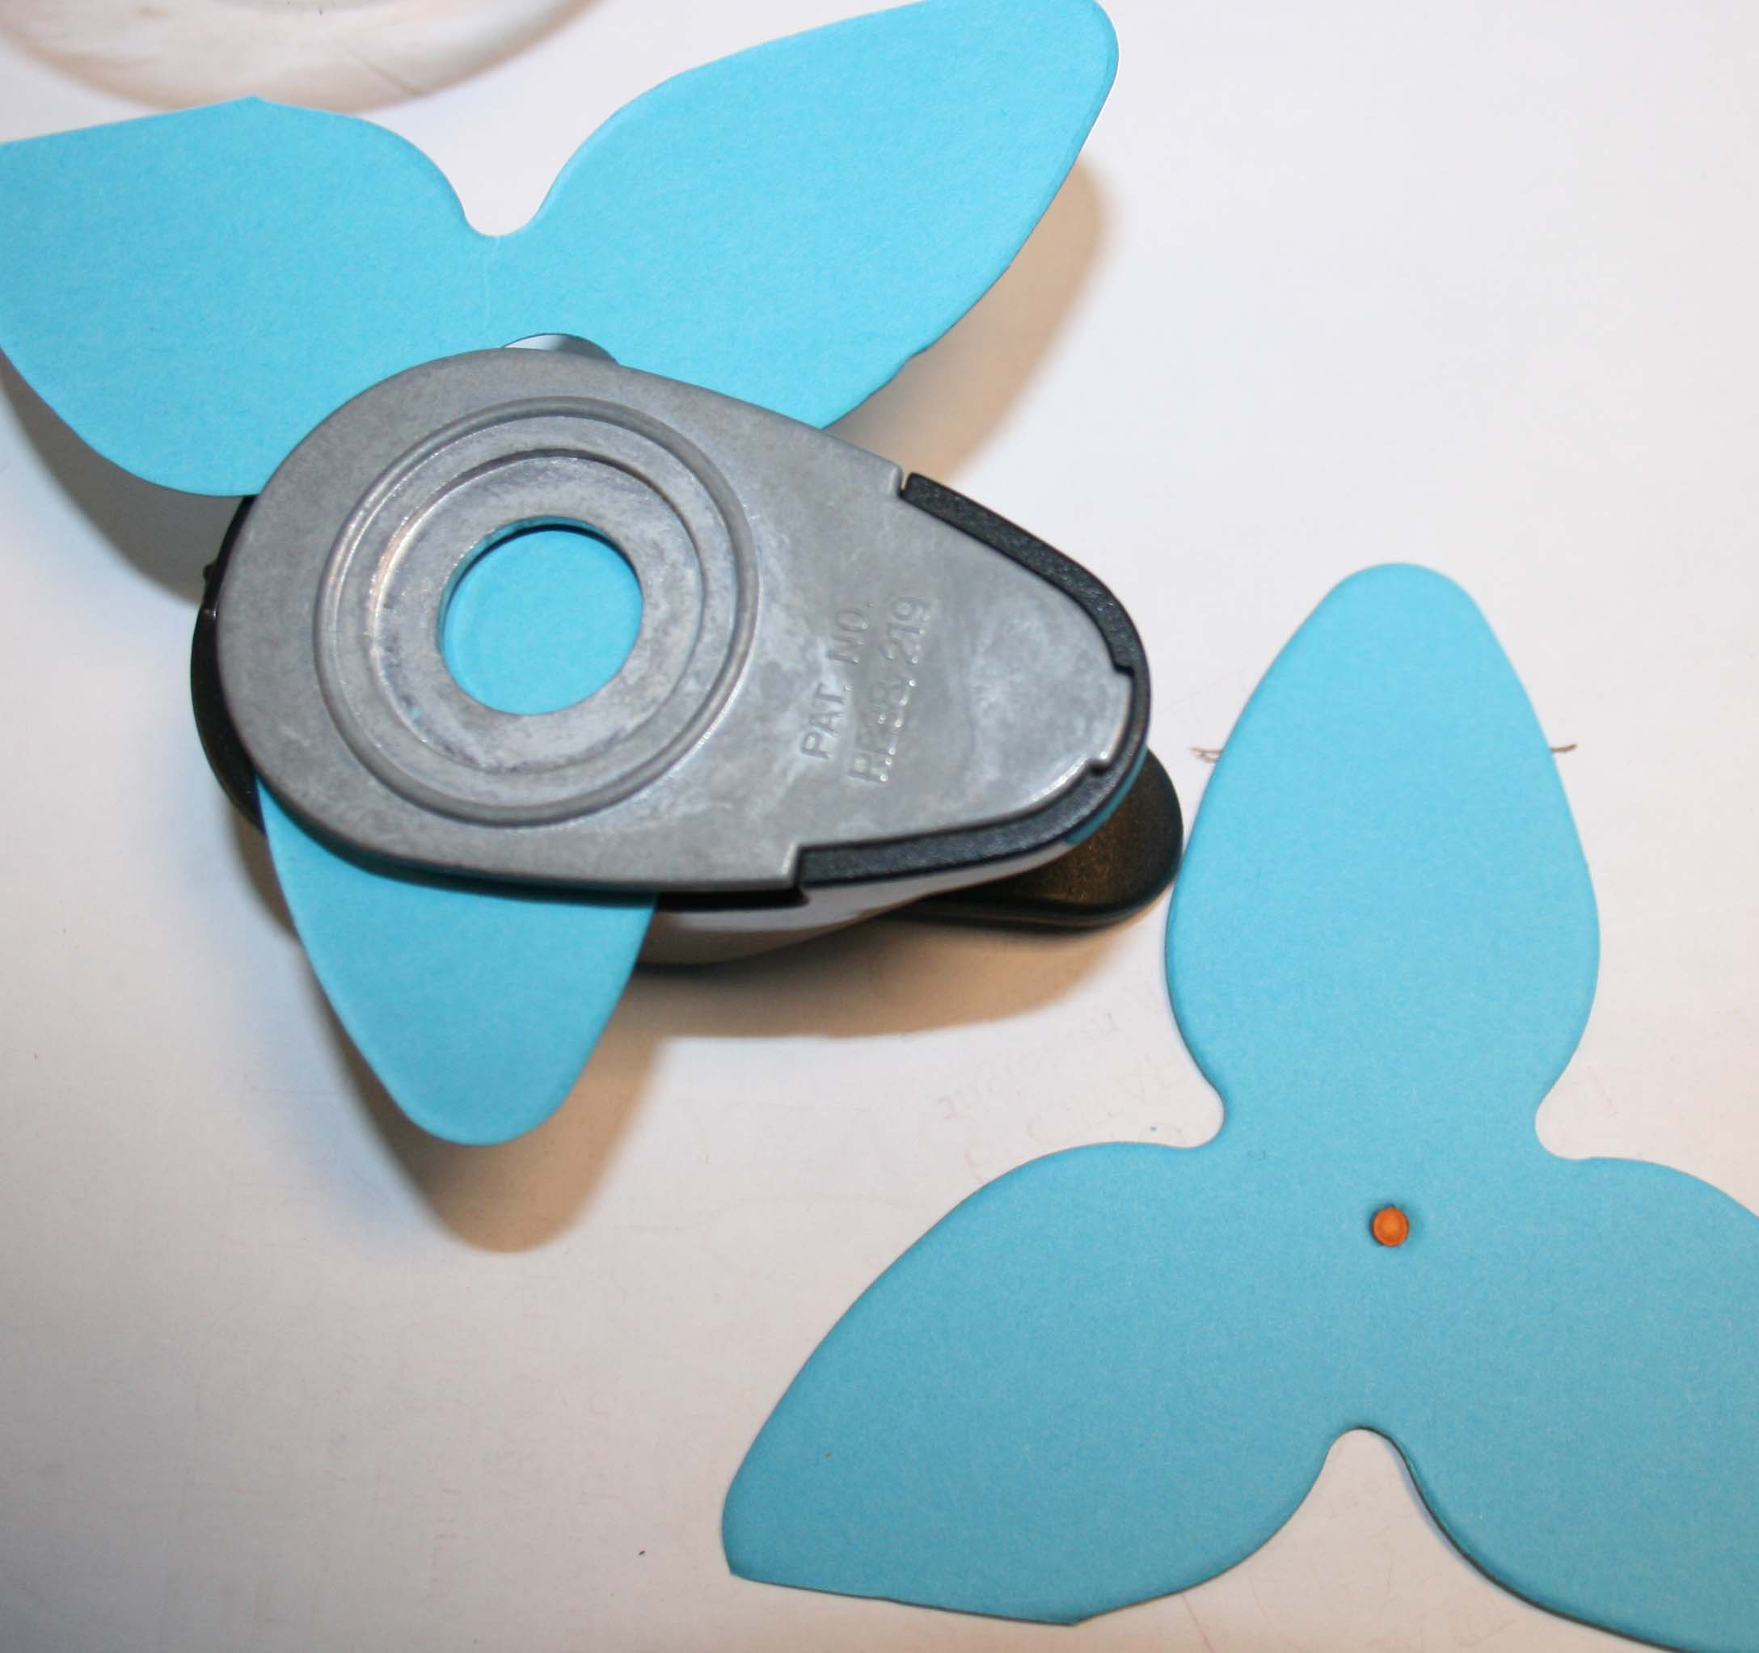 | Create larger hole in flowers cut from Island Floral die cut – size of opening needed will be determined by lights purchased.
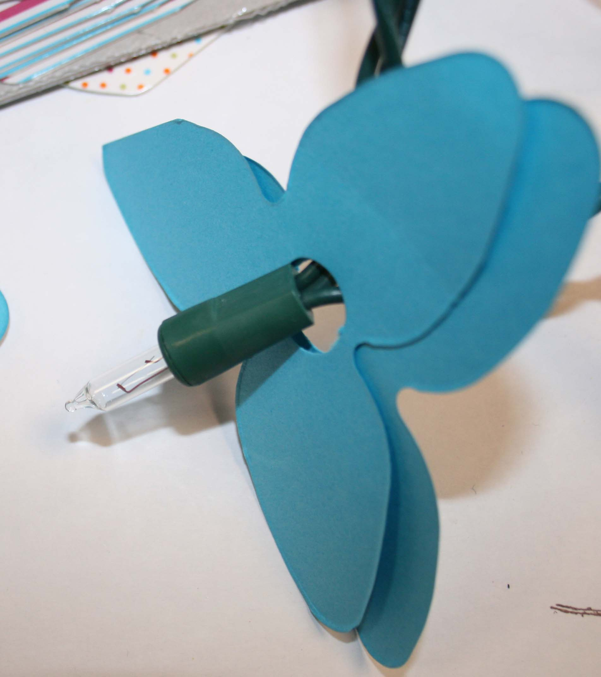 | Remove cover from bulb and slide flowers over bulb
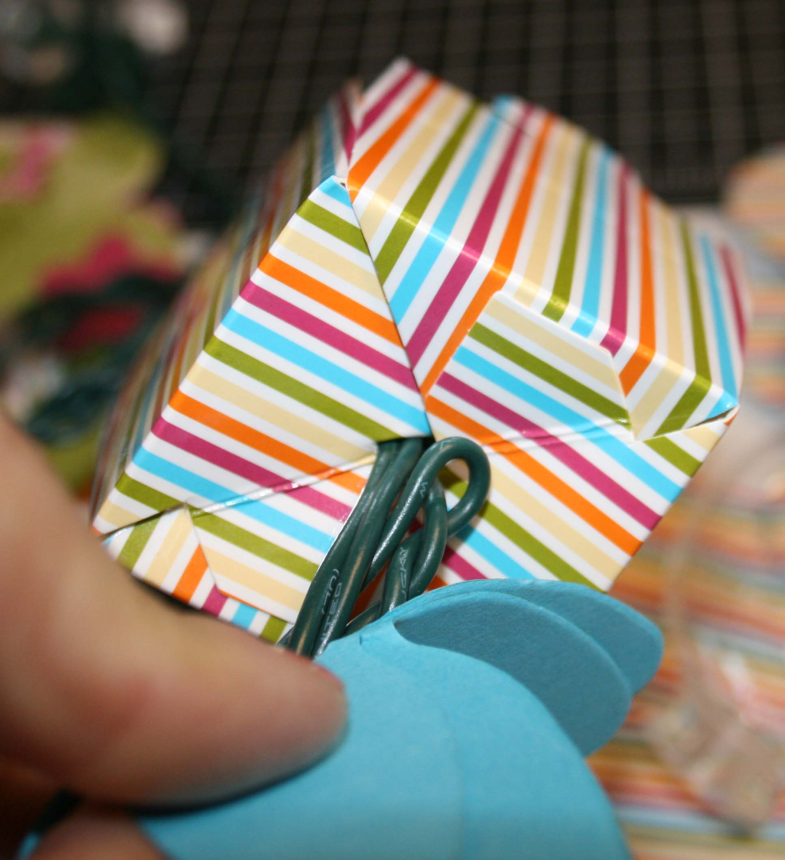 | Insert bulb into box – no need to make a hole
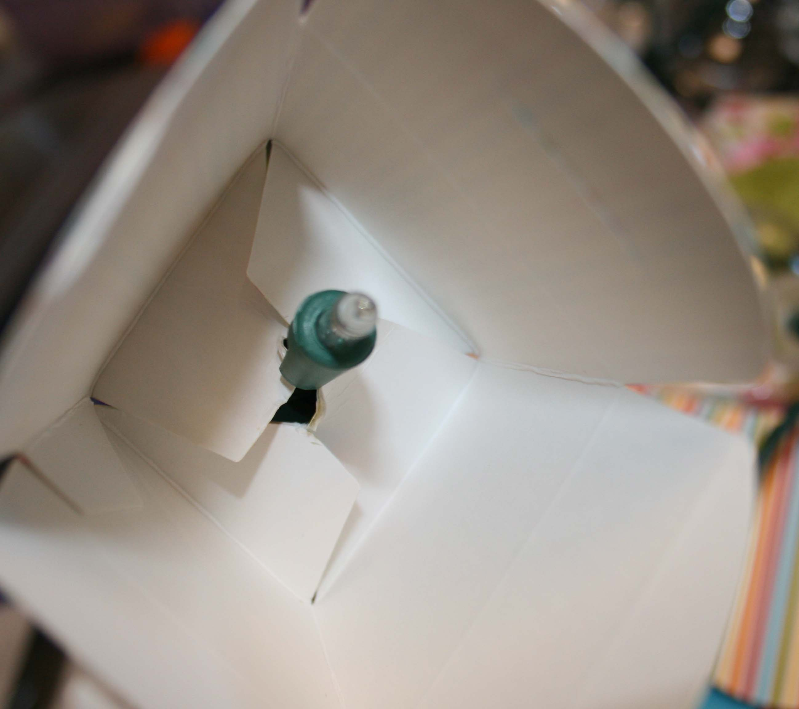 | Replace cover over bulb
